**Submission for Assignment 03**______________________________________________________________________________

**Task 1**

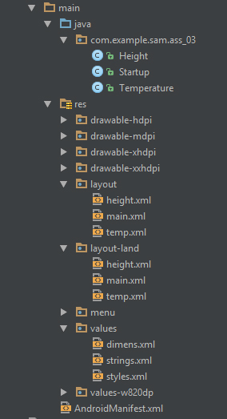

// Start the Temperature Conversion Activity

public void tempActivity(View view) {  
 Intent intent = new Intent(this, Temperature.class);  
 startActivity(intent);  
 }

// Start the Height Conversion Activity  
public void heightActivity(View view) {  
 Intent intent = new Intent(this, Height.class);  
 startActivity(intent);  
 }

**main.xml -**

<!-- onClick to call Temperature Activity -->  
<Button android:id="@+id/tempButton"  
 android:onClick="tempActivity" />

<!-- onClick to call Height Activity -->  
<Button android:id="@+id/heightButton"  
 android:onClick="heightActivity" />

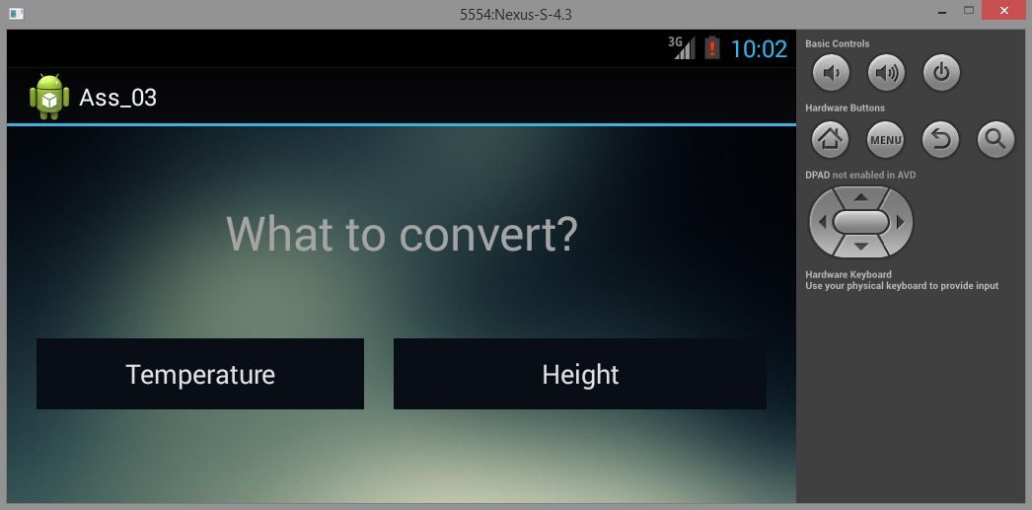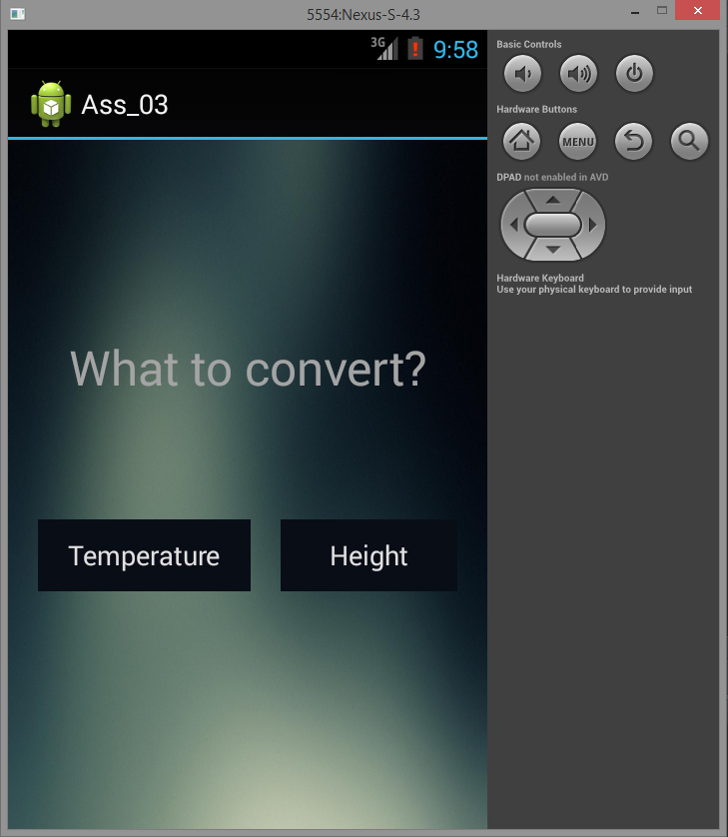

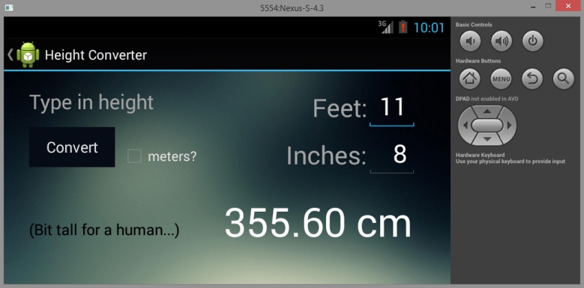

**AndroidManifest.xml -**

<activity android:name="com.example.sam.ass_03.Height"  
android:label="@string/heightTitle" android:parentActivityName="com.example.sam.ass_03.Startup" >

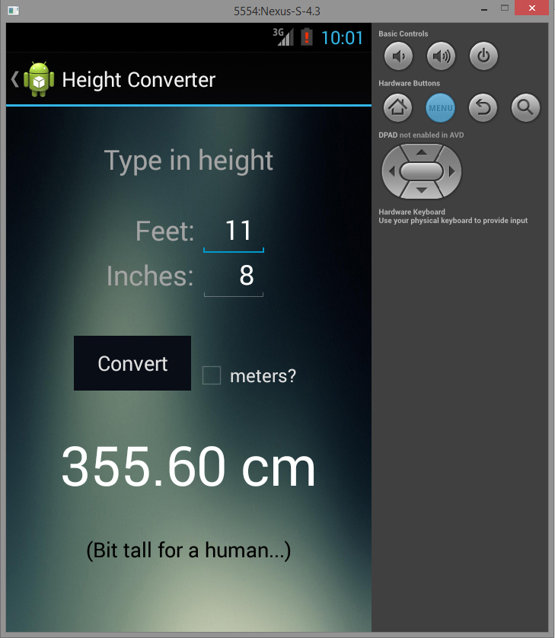<meta-data android:name="android.support.PARENT_ACTIVITY" android:value="com.example.sam.ass_03.Startup" />  
 </activity>

**height.xml -**

<TextView android:id= "@+id/unRealisticHuman"  
...  
android:freezesText="true" />

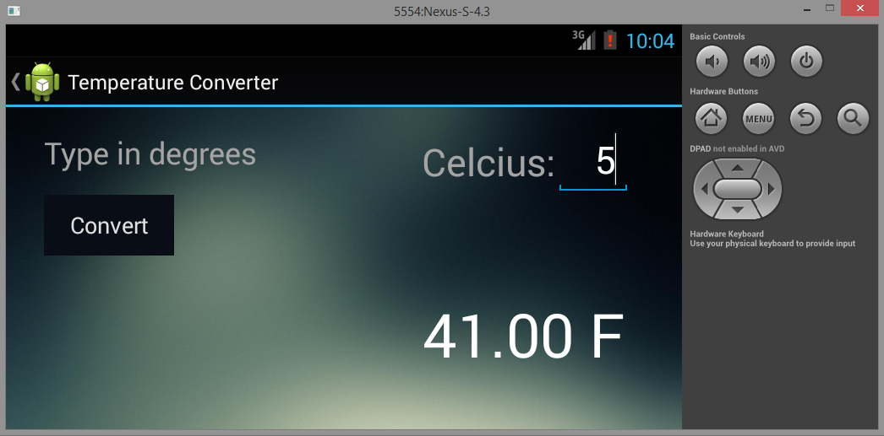

**AndroidManifest.xml -**

<activity android:name="com.example.sam.ass_03.Height"  
android:label="@string/tempTitle" android:parentActivityName="com.example.sam.ass_03.Startup" >

<meta-data android:name="android.support.PARENT_ACTIVITY" android:value="com.example.sam.ass_03.Startup" />  
 </activity>

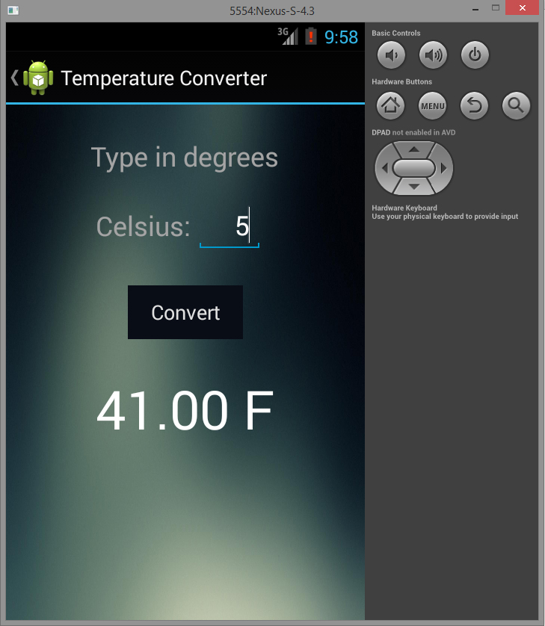

**temp.xml -**

<TextView android:id="@+id/convertedTempTextView"  
...  
android:freezesText="true" />

**Task 2**

**MainActivity.java -**

public void onCreate(Bundle savedInstanceState) {  
 super.onCreate(savedInstanceState);  
 setContentView(R.layout.main);  
 }

// Data for each of the foods (description, title, image)  
 public void souvlakiImgBtn(View v) { showFoodView("\"Greek fast food consisting of small pieces of meat and sometimes vegetables grilled on a skewer.\"", "Souvlaki", R.drawable.souvlaki); }  
public void pieImgBtn(View v) { showFoodView("\"A French Canadian dish similar to English cottage pie or shepherd's pie.\"", "Pâté Chinois", R.drawable.pie); }  
 public void dumplingImgBtn(View v) { showFoodView("\"Wontons filled with pork and served with a peanut butter chili sauce.\"", "Peanut Butter Dumplings", R.drawable.dumpling); }  
public void cakeImgBtn(View v) { showFoodView("\"A cake, often sponge cake, which is made with coffee or has a coffee flavor.\"", "Coffee Cake", R.drawable.cake); }

private void showFoodView(String foodDesc, String foodName, int drawableImage) {  
 Bundle dataBundle = new Bundle();  
 dataBundle.putString("description", foodDesc);  
 dataBundle.putString("name", foodName);  
 dataBundle.putInt("image", drawableImage);

// Start the Activity and Create the Bundle of information to be sent  
 Intent intent = new Intent();  
 intent.setClass(getApplicationContext(), ImageDisplay.class);  
 intent.putExtras(dataBundle);   
 startActivity(intent);

}

**ImageDisplay.java -**

public void onCreate(Bundle savedInstanceState) {  
 super.onCreate(savedInstanceState);  
 setContentView(R.layout.foodview);  
 initializeUI();  
}

private void initializeUI() {  
 // Pull the data from MainActivity.java  
 Bundle dataBundle = getIntent().getExtras();  
 String foodDesc = dataBundle.getString("description");  
 String foodName = dataBundle.getString("name");  
 Drawable foodImg = getResources().getDrawable(dataBundle.getInt("image"));

// Find the data that needs to be replaced  
 TextView foodDescView = (TextView) findViewById(R.id.foodDescView);  
 TextView foodTextView = (TextView) findViewById(R.id.foodTextView);  
 android.widget.ImageView foodImageView = (android.widget.ImageView) findViewById(R.id.foodImageView);

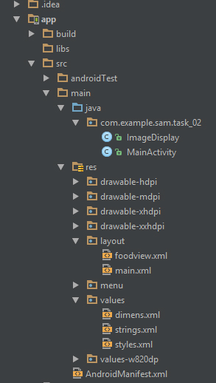

// Replace data with the correct information  
 foodDescView.setText(foodDesc);  
 foodTextView.setText(foodName);  
 foodImageView.setImageDrawable(foodImg);  
 }

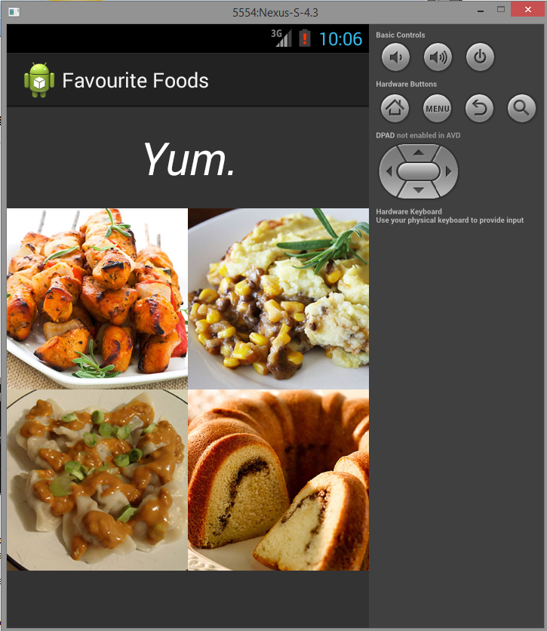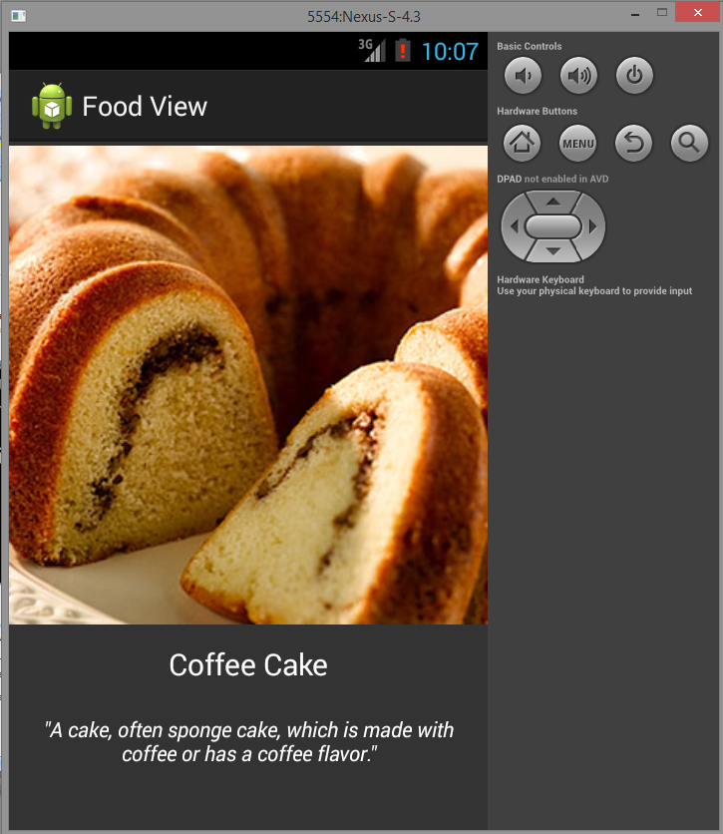

**main.xml -**

<TableLayout  
android:layout_width="match_parent"  
android:layout_height="match_parent">

<TableRow  
android:layout_height="wrap_content"  
android:layout_width="fill_parent"  
android:gravity="center_horizontal">

<TextView  
android:layout_width="match_parent"  
 android:layout_height="wrap_content"  
android:textSize="40dp"  
android:text="@string/title"  
android:gravity="center"  
android:layout_span="2"  
android:padding="18dip"  
android:textColor="#fff"  
android:textStyle="italic"/>  
</TableRow>

<TableRow  
android:layout_height="wrap_content"  
android:layout_width="fill_parent"  
android:gravity="center_horizontal">

<ImageView  
android:id="@+id/souvlakiMini"  
android:src="@drawable/souvlaki"  
android:layout_width="wrap_content"

android:layout_height="160dp"

android:layout_weight="1"

android:onClick="souvlakiImgBtn" />

<ImageView

android:id="@+id/pieMini"

android:src="@drawable/pie"

android:layout_width="wrap_content"

android:layout_height="160dp"

android:layout_weight="1"

android:onClick="pieImgBtn" />

</TableRow>

<TableRow  
android:layout_height="wrap_content"

android:layout_width="fill_parent"

android:gravity="center_horizontal">

<ImageView

android:id="@+id/dumplingMini"

android:src="@drawable/dumpling"

android:layout_width="wrap_content"

android:layout_height="160dp"

android:layout_weight="1"

android:onClick="dumplingImgBtn"

/>

<ImageView

android:id="@+id/cakeMini"

android:src="@drawable/cake"

android:layout_width="wrap_content"

android:layout_height="160dp"

android:layout_weight="1"

android:onClick="cakeImgBtn"

/>

</TableRow>

</TableLayout>

</LinearLayout>

**Task 3**

**(a) Why is the intent messaging facility considered as a late run-time binding between**

**components?**

It is the only means of communicating between applications (creating new activities within other apps, broadcasting, etc.), and it is the only way to utilize multiple activities in your application.

**(b)What are the contents of the passive data structure (of an intent)?**

Creating the intent, finding out the parameters of the program planning on using the intent, and then setting the information so that can be accessed by the application.

Intent intent = new Intent();

intent.setClass(getApplicationContext(), ImageDisplay.class);

intent.putExtras(dataBundle);

startActivity(intent);

**(c) Why is the word “passive” used for the intent data structure?**

The intent acts purely as a message, it only indicates that there is something that needs to be done, it does not actually execute the task. (For example, in startActivity(intent) it is not the intent doing the actual work, but the startActivity(); )

**(d) Use an example to better explain the sentence “abstract description of an operation**

**to be performed”.**

intent.setClass(getApplicationContext(), ImageDisplay.class);

intent.putExtras(dataBundle);